**Python – Retrieving data from a database – Exercises**

1. Retrieve the first row (all columns) from the product table and print it to the screen as follows:

(100860, 'ACE TENNIS RACKET I')

2a. Retrieve the custid, area and name for all customers and print each row without any formatting as follows:

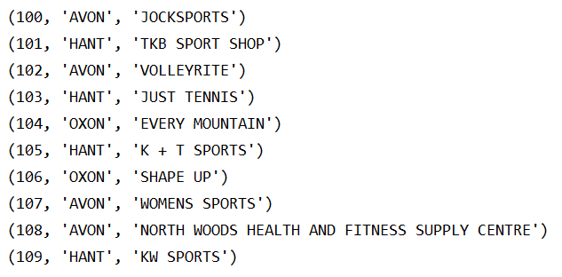

2b. Modify the code from 2a and print the output tab-separated as follows:

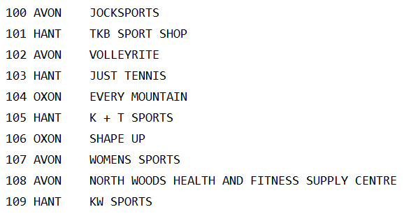

1. Accept input of a customer id and retrieve the name and credit limit for the customer and print the details as shown below (formatting the credit limit with two decimal places and prefixing with a £-sign. If the user enters an invalid customer id, display the error “No customer found with that id”



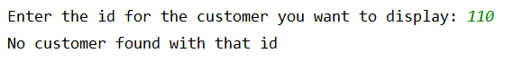

4. Print the manager names and the names of the employees that they manage (including the President who doesn’t have a manager) as follows:

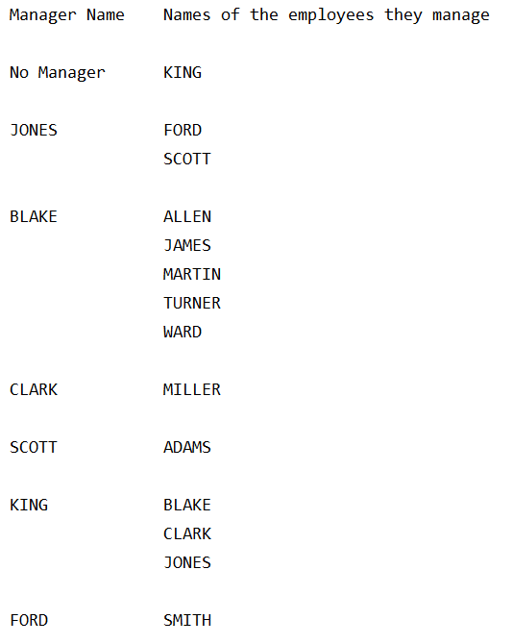

5a. Accept the input of an order number and display the following details in relation to each item for that order. Sort results by item id. If the order id entered is not valid, display the error “No order found with that id”.

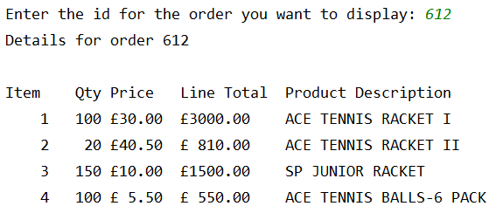

5b. Modify the code from question 5a to show the order total at the end as follows:

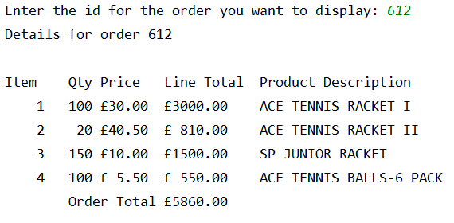

6. Prompt the user to enter a product code and a minimum order quantity and display the following information in relation to every customer that has placed an order for at least the entered minimum quantity of the entered product. Sort results by customer id and then order id. If no rows match the selection criteria, print the error "No customers have placed an order for that number of the selected product"

